App Dev Project -1 Report
1. Student Details
Name: Narukulla Akhila
Roll Number:24F2001995
Email: 24f2001995@ds.study.iitm.ac.in
About Me: I am an undergraduate Computer Science student pursuing a B.S. Degree in Data Science and Applications from IIT Madras alongside a B.Tech in Computer Science and Engineering (Artificial Intelligence & Machine Learning). I enjoy coding, solving programming problems, and learning about Artificial Intelligence, Machine Learning, and Data Science.
2. Project Details
Project Title: Trekking Management Application
Problem Statement:
To design and build a web-based Trekking Management Application that allows administrators to manage treks, staff, and users, staff to manage assigned treks, and users to browse, book, and track trekking activities.
Approach:
The application was built using Flask as the backend framework with a modular structure. It allows administrators to manage treks and staff, staff members to manage assigned treks and participants, and users to browse, search, filter, and book treks through separate role-based dashboards.

3. AI/LLM Declaration
I used ChatGPT (GPT-5.5) to assist with understanding Flask concepts, debugging, code suggestions, improving HTML templates, and preparing project documentation.
The extent of AI/LLM usage is approximately 25%. All final implementation, integration, testing, and validation were carried out by me.
4. Technologies and Frameworks Used
Technology / Library | Purpose
Flask | Core Python web framework used to build the application.
Flask-SQLAlchemy | ORM used to define models and interact with the SQLite database.
SQLite | Lightweight relational database used to store users, treks, bookings, and staff information.
Jinja2 | Template engine used to render dynamic HTML pages with data from Flask.
HTML5 | Structure of the web pages and forms.
CSS3 | Custom styling for the application interface.
Bootstrap 5 | Responsive layout, navigation bar, tables, forms, buttons, and cards.
Python | Backend programming language for implementing application logic.

5. Database Schema / ER Diagram
Table | Columns | Constraints / Description
User | id, name, email, password, role, phone, is_approved, is_blacklisted | id – Primary Key, email – Unique, name, email, password, role – NOT NULL
Trek | id, name, location, difficulty, duration, available_slots, assigned_staff_id, status, start_date, end_date | id – Primary Key, assigned_staff_id – Foreign Key → users.id, mandatory fields are NOT NULL
Booking | id, user_id, trek_id, booking_date, status, payment_status, attendance | id – Primary Key, user_id – Foreign Key → users.id, trek_id – Foreign Key → treks.id, booking date stored automatically
StaffProfile | id, user_id, experience, contact_details | id – Primary Key, user_id – Foreign Key → users.id

ER diagram: -
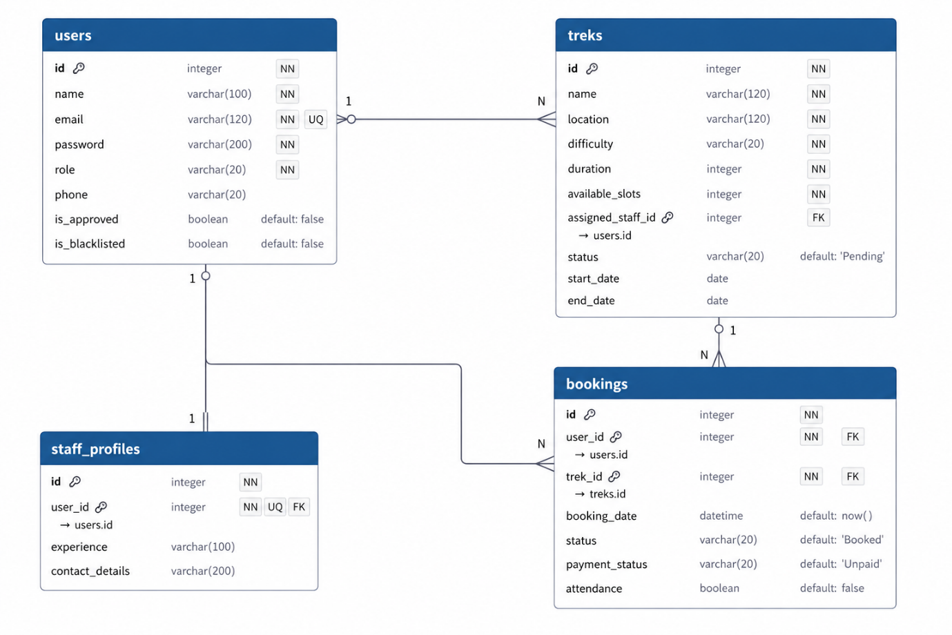
6. API Resource Endpoints
REST APIs were not implemented in this project.
7. Architecture and Features (optional)
Architecture Overview:
- app.py – main Flask application entry point
- /models – database models using SQLAlchemy
- /routes – Flask Blueprints for user and activity routes
- /templates – Jinja2 HTML templates
- /static – CSS
Implemented Features
- User, Staff, and Admin authentication.
- Role-based dashboards.
- Trek creation, editing, deletion, and staff assignment.
- Trek booking with overbooking prevention.
- Trek search and filtering by location and difficulty.
- Booking history, payment status, and cancellation management.
- Responsive user interface built using Bootstrap.
Additional Features
- User and Staff profile editing.
- Automatic slot restoration after booking cancellation.
- View and manage participants for Admin and assigned Staff.
- Dashboard statistics for all user roles.
- User and Staff blacklisting/unblacklisting.
- Search by both Name and ID.
- Attendance marking by staff for a trek assigned to them.

8. Video Presentation
Drive Link:

